import pandas as pd

import matplotlib.pyplot as plt

df = pd.read_excel (r'C:\Users\91845\Desktop\Plots project\SvsTime.xlsx')

df=df.iloc[: , :6]

S(ti+1)=S(ti)-Q∫_0^∞▒dr r3{n(r,ti+1)-n(r,ti)}+(A[P]∆t)/[C]_∞ e^(〖-E〗_A/RT)

x_1=df['time_1.5K']

y_1=df['S_1.5K']

x_3=df['time_3.5K']

y_3=df['S_3.5K']

x_6=df['time_6.5']

y_6=df['S_6.5K']

plt.plot(x_1,y_1)

plt.plot(x_3,y_3)

plt.plot(x_6,y_6)

plt.xlabel('Time s')

plt.ylabel('Supersaturation S')

plt.legend(['1.5K/min','3.5K/min','6.5K/m'])

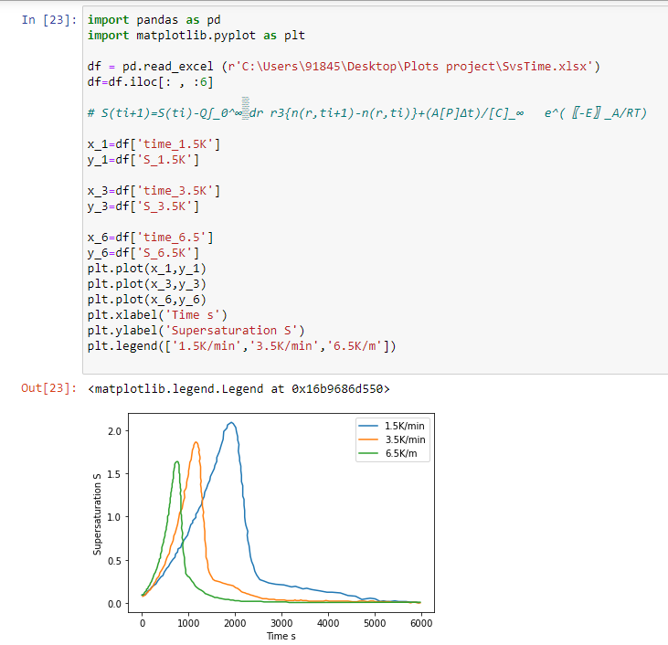

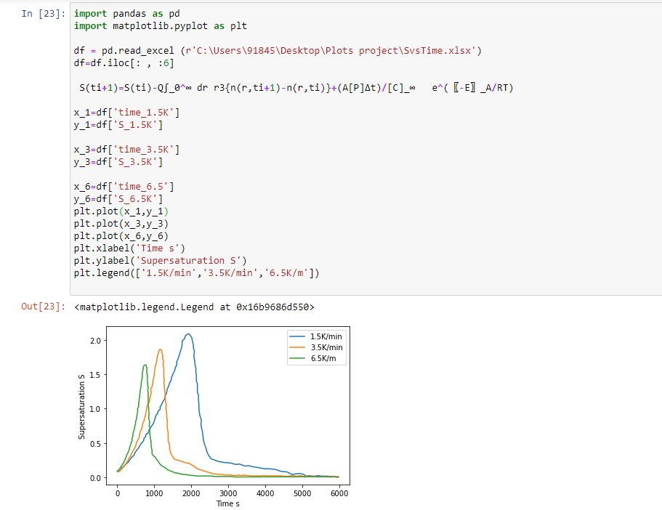

# CHAPTER 3. MODELING AND SIMULATION

**3.1 EXPERIMENTAL SECTION (Chemicals Used)**

The chemicals used were iron (III) acetylacetonate (97%) as well as oleylamine (OAM, >70%), benzyl ether (BE, technical grade 98%), oleic acid (OAC, technical grade 90%), hexane, ethanol, acetone, hexadecandiol (99 percent). All chemicals were utilised exactly as they were given to us. In a threenecked round-bottom flask under a mild flow of N2, 2.0 mmol iron acetylacetonate, 10 mmol hexadecandiol, 6 mmol oleylamine, and 6 mmol oleic acid were combined in 20 mL benzyl ether to make the NPs.

The mixture was magnetically swirled and degassed for 60 minutes at 383 K (110 °C) under vacuum (0.10.2 mbar). The temperature was subsequently elevated to 453 K (180 °C) using N2 blanketing at a heating rate (HR) of around 6.5 K/min. The solution was kept at 453 K for 2 h.

**3.2 A Theoretical Model for the “Heating-Up” Process**

**3.2.1 Thermal Decomposition of Iron-Oleate Complex.**

Through the formation of thermal free radicals the decomposition reaction of transition metal carboxylates occurs.

When the M-O and MO-C bonds of a metal carboxylate break, radical species occur, as shown.

M-OOCR → M•+RCOO•

M-OOCR → MO•+RC•O

To propagate the decomposition reaction, these radical species can recombine, decompose into smaller molecules, or react with other metal carboxylate molecules.

**3.2.2 Theoretical model for the synthesis of the nanocrystals**

**Process 1** (prenucleation stage)

P 🡪 M {P-Precursor ,M-Monomer}

**Process 2** (nucleation stage)

xM 🡪 Cx{Cx-crystal particle containing x monomer}

**Process 3** (growth stage)

Cx +yM 🡪 Cx+y

In Process 3 supersaturation S=[M]/[M]eq

{ [M]eq-Monomer concentration in equilibrium }

**3.3.3 Equations**

**3.3.3.1 The equation of nucleation rate of reaction of Process II is as follows:**

S>1

$$\frac{dN}{dt}=Aexp[ \frac{-163Vm3}{3KbT^{3}{NA}^{2}(ln{ S)}^{2}} ]$$

N - number of crystal particles

t – time

A - constant

γ - surface free energy per unit area

Vm - molar volume of crystal

kB - Boltzmann constant

T –temperature

NA - Avogadro’s number

**3.3.3.2 Growth rate of a particle from process III is as follows:**

$$\frac{dr}{dt}=VmD\left[M\right]\left[\frac{S-exp⁡[\frac{2Vm}{rRT}]}{r+\frac{D}{kpo}exp⁡[\frac{2Vm}{rRT}]}\right]$$

D - Diffusion coefficient of the monomer

k°p - precipitation reaction constant of the monomer on the surface of bulk crystal,

- Transfer coefficient for the precipitation/dissolution reaction.

R – Gas constant

**3.3.4 Details of Simulation:**

**3.3.4.1 Standard population balance model**

$\frac{N(r,t)}{t}+\frac{[N\left(r,t\right) (r,t)]}{t}=Rnucg(r)$

Where

N(r,t) is Number of particle of radius r at time t,

$(r,t)$ is the instantaneous growth rate,

Rnuc is the nucleation rate,

g(r) is the nucleation distribution function.

The surface free of a particle of radius ­ r is ΔGs=4πr2γ where γ is the surface energy. The bulk free energy is given by ΔGv= $\frac{4r^{3}RT }{3Vm}\ln{S}$

R= gas constant

T- temperature

Vm- molar volume of monomer

S-Supersaturation

The nucleation process occurs for the particles having a radius comparable to the critical radius, which is obtained by the minimization of total free energy ΔGT=ΔGv+ ΔGs with respect to the particle radius ­r.

rc=

The nucleation rate for the system containing monomer of size rm and volume Vm is given as follows:

Rnuc=8πrmDNASpu+1[C]2∞ exp{ }

D - monomer diffusion coefficient

NA  - Avogadro constant

S- The dimensionless supersaturation defined as the bulk concentration of the monomer normalized to equilibrium concentration of the monomers.

exponents of the supersaturation are the normalized critical radius to the monomer radius,

p=(rc/rm)3

u - coagulation parameter

surface energy γ normalized to the thermal energy KBT.

**3.3.4.2 Nucleation Distribution Function g(r)**

g(r)= $\frac{1}{√2}exp⁡(\frac{-k{\left(r-rc\right)}^{2}}{2{}^{2}})$

k=1 kJ mol-1 nm-1

${}^{2}$ =KBT/2

**3.3.4.3 Instantaneous Growth Rate of a Particle**

Γ(r,t)= $\frac{dr}{ⅆt}$ = $\frac{DVmS(1-exp⁡(2Vm/rRT)}{(r+\frac{D}{Kr})}$

**3.3.4.2 The dynamics of the precursor release**

$\frac{d[P]}{dt}$ = $\frac{-d[C]}{dt}$ = -A exp(-EA/RT)[P]

A - prefactor

EA –precursor to monomer activation energy

**3.3.4.3 Generalized Equation for the Supersaturation**

S(ti+1)=S(ti)-Q r3{n(r,ti+1)-n(r,ti)}+ $\frac{A[P]∆t}{{\left[C\right]}_{∞}} e^{\frac{{-E}_{A}}{RT}}$

**3.3.4.4 heating rate**

$$\frac{dT}{dt}=H_{R} for T≤T_{f}$$

**Code and Results**